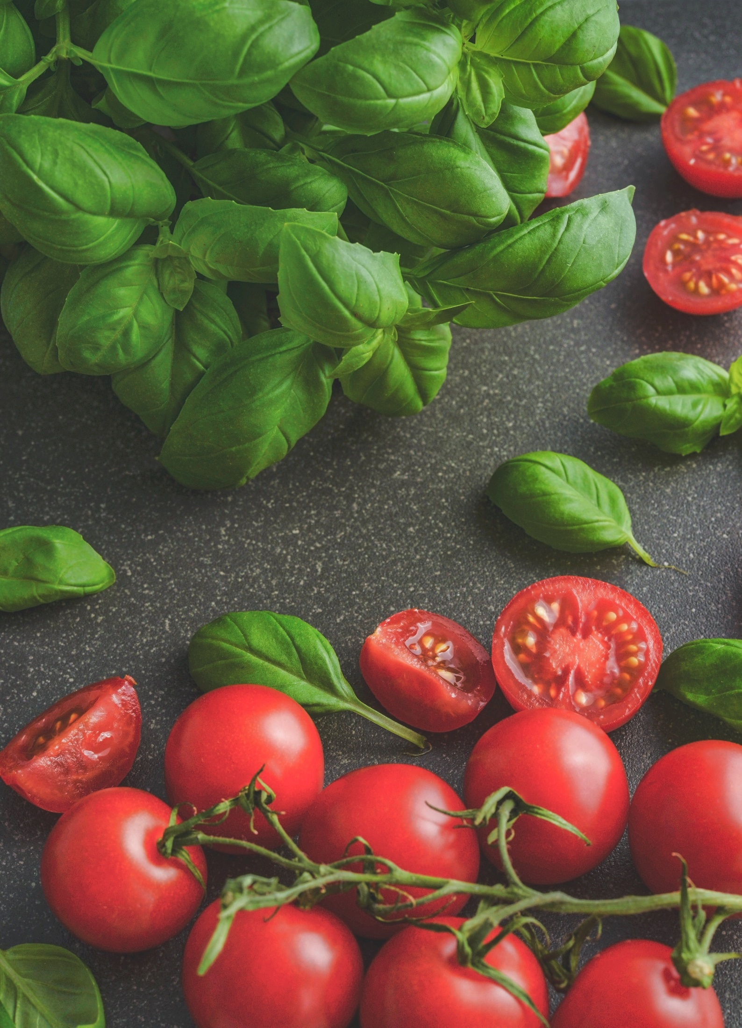

LOREM IPSUM

Lorem ipsum dolor sit

LOREM IPSUM DOLOR SIT dolo

Lorem ipsum dolor sit amet consectetur adipiscing elit commodo, facilisi sociosqu sodales rhoncus in malesuada inceptos.